DATE: 17.05.2019
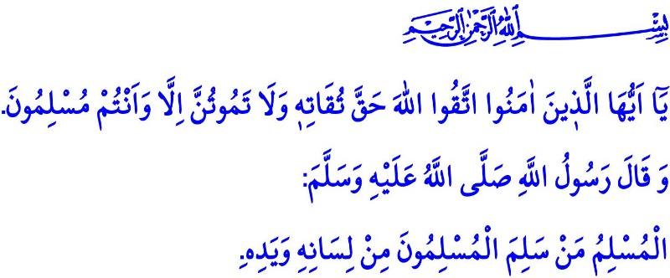
A GOOD MUSLIM ACCORDING TO THE PROPHET MUHAMMAD (SAW)
Honorable Muslims!
The Almighty Allah (swt) states in the verse I have just recited: “O ye who believe! Fear Allah as He should be feared, and die not except in a state of Islam.”
Prophet Muhammad (saw) says in the hadith I have recited: “A Muslim is he from whose hand and tongue the Muslims are safe.”
Dear Muslims!
The most precious treasure of Muslims is their iman. Iman is the biggest blessing that will rejoin us with peace in this world and with salvation in the Hereafter. The Prophet Muhammad (saw) gives glad tidings to the ones who own this blessing: “Whoever testifies sincerely that there is no god but Allah and that Muhammad is the messenger of Allah, Allah would prohibit the fire of hell for him.”
Iman is an unequalled jewel and a unique opportunity. Iman is recovery for sorrows and shield against sins. It is a power that protects Believers from evil under any circumstances and that leads them to benevolence. A person who values iman should preserve his iman and exercise due care to live a life suitable to his iman. Then he will be closer to the Almighty Allah (swt) and will be released from being slave of the meaningless desires and nine days’ wonders.
Honorable Muslims!
The way of strengthening the iman in our hearts is not to skip our worships, because iman is fed with worship. Worship is the essence of servitude and the purpose of the creation of human. It is to submit our condition to the Almighty Allah (swt) without any mediator and means. The Messenger of Allah (saw) advices believers on this issue: “Keep worshipping, establishing fard (obligatory) prayers, giving fard zakat and observing the fasting in Ramadan without assigning partners to Allah. Behave towards people in a way you would like to be behaved."
Then the requirements of your loyalty to tawhid and the iman to Allah (swt) are primarily to perform the fard worships such as prayer, fasting, zakat and hajj. It is the virtue of Muslims to try to receive consent of their Almighty Allah (swt) by means of nafl (supererogatory) worships.
Honorable Believers!
What completes iman and worship is only the good morals. The Messenger of Allah (saw) states in a hadith, “The most complete of the believers in faith are those with best character." To adopt moral virtues and to stay away from ill tempers are essential responsibilities of believers.
Believers take our Prophet Muhammad (saw) “who was only sent to perfect good character”as an example at every stage of their lives. They have mercy on the young people and show respect to the elders. They assure the people around them and observe whatever entrusted to them. They are truthful and do not resort to lies. They are generous and do not be stingy. They behave towards their mother, father, spouse, children and all creatures animate or inanimate with affection and never resort to violence.
Honorable Believers!
What a great honour to be a member of the ummah of Muhammad (saw)! However, being the members of the best ummah selected out of the family of humanity requires responsibility at the same time. When we read the hadiths of our Beloved Prophet (saw) we see that he describes a Muslim as follows: A Muslim is person who knows that he will not enter Paradise until he have faith and will not have faith until he loves his brothers. Muslim is a person who becomes happy when he does a favour and gets sad when he does an evil. Muslim does not defame and curse people, does not use rude and bad words and does not be shameless. He stays away from alcohol, the mother of evils, from gambling, which wastes his life, and from adultery, which requires the wrath of Allah (swt). Muslim avoids assigning partners to Allah (swt), does not murder people, does not utilize interest and does not take advantage of the wealth of an orphan. Muslim does not slander his brothers and sisters, does not be talebearer and does not take part in fitnah and mischief.
Dear Muslims!
The Messenger of Allah (saw) says in a hadith: “The best of you is the one from whom people expect good deeds, and from whose evil deeds people are safe; the worst of you is the one from whom people expect good deeds but from whose evil deeds people are not safe.” Then, let us exert efforts to be a good Muslim as our Prophet Muhammad (saw) taught us. Let us enlighten our hearts with iman. Let us feed them with worships. Let us polish them with good deeds and good morals. Let us be the key for goodness and the lock against evil at every stage of our lives.
Honorable Believers!
While ending my khutbah I would like to share an issue with you. Under the leadership of our Presidency of Religious Affairs and our Turkiye Diyanet Foundation, services are taken to every corner of our country and to every part of the world thanks to the support of our self-sacrificing nation. Healthy accommodation environments are prepared for our students, they are provided with scholarship and educational and cultural support, our orphan and poor brothers and sisters are supported with free education. In this unique climate of the month of Ramadan, you can be light of hope for thousands of young people by means of zakat, sadaqah al-fitr and donations and cover for their needs. Within this scope, following the Friday prayer, we will resort to your aids full of love, affection and brotherhood. May the Almighty Allah (swt) accept all of our previous and future aids in the presence of Him.

Ali 'Imran, 3/102.
Muslim, Iman, 65; Bukhari, Iman, 4.
Bukhari, 'Ilm, 49.
Ibn Hanbal, VI, 384.
Abu Dawud, Sunnah, 15.
Ibn Hanbal, II, 381.
Muslim, Iman, 93.
Ibn Hanbal, IV, 399.
Tirmidhi, Birr, 48.
Ibn Majah, Ashriba, 1; Abu Dawud, Ashriba, 5; Bukhari, Qusuf, 2.
Bukhari, Wasaya, 23; Tabarani, al-Majmua al-Qabir, XII, 340.
Tirmidhi, Fitan, 76; Ibn Hanbal, II, 368. General Directorate of Religious Services

